**Test Complete:**

Testcomplete is a software automation tool, developed by smart bear which allow us to create powerful and reusable test for mobile, desktop and web application.

Testcomplete supports various types of automation testing like unit testing, smoke testing, regression testing, functional, distributed and load testing.

Testcomplete supports various scripting language like VBScript, Jscript, C#, C++, Delphi.

Double Slash is used to comment in Testcomplete

To call routine, variable, constant declared from one unit to another unit, we use USEUNIT statement in testcomplete.

There are different ways for capturing the object in testcomplete.

* Recording
* Object spy
* Find, FindAll, FindChild, FindAllChildren

There are two ways for creating variable:

* By clicking on Add Variable tab
* By right clicking on the editor and select Add variable

**TestComplete steps:**

1. Open the testcomplete application and it looks like shown below and click on New Project to create a new project.

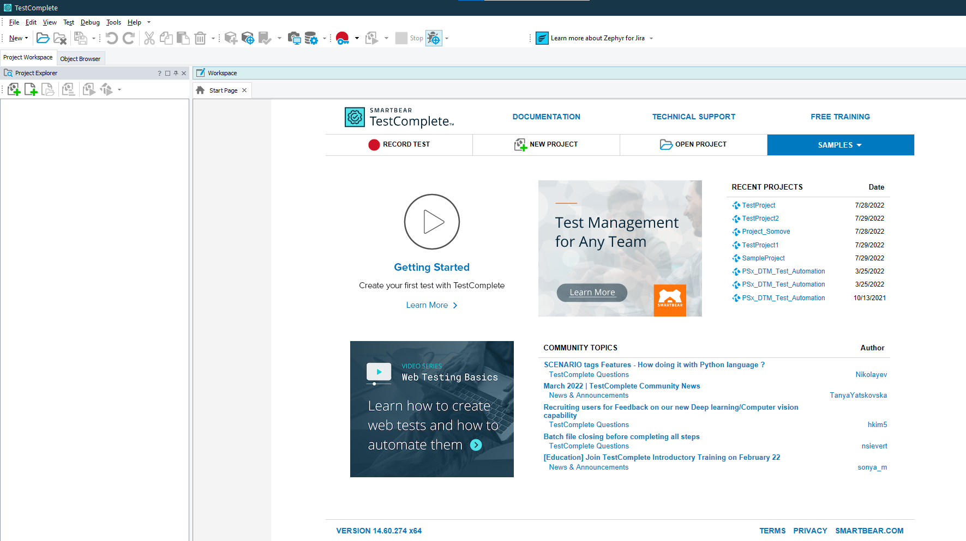

1. Enter the project name ,scripting language, project location and click finish.

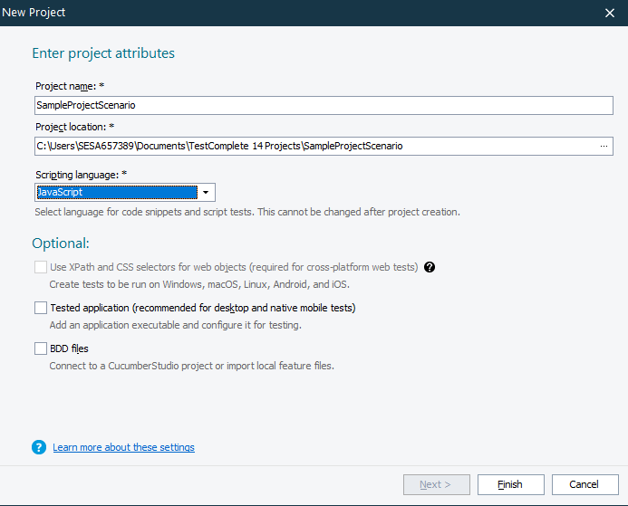

1. To add tested application right click on the project and select new item as shown below.

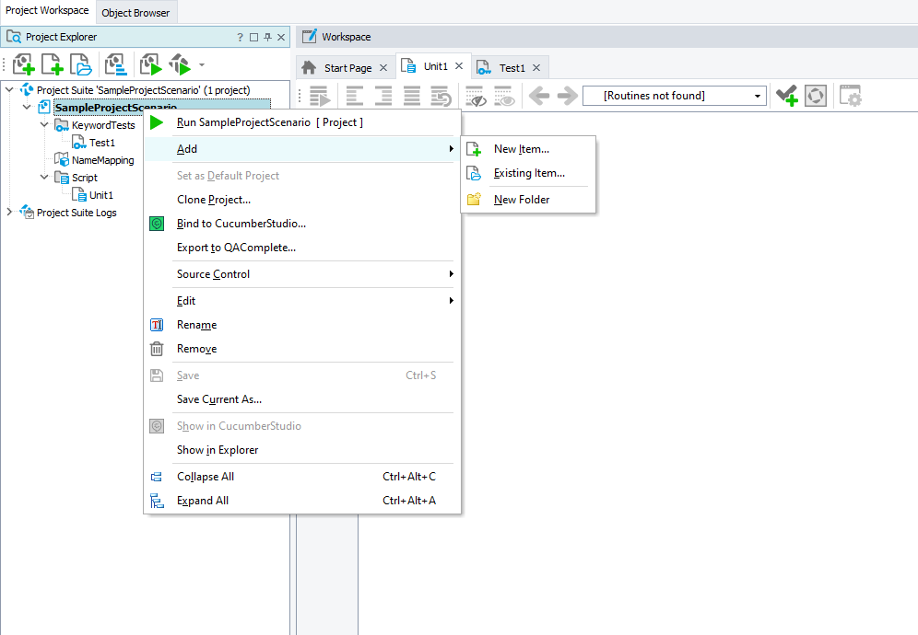

1. Popup will get ,select tested applications and click OK as shown below.

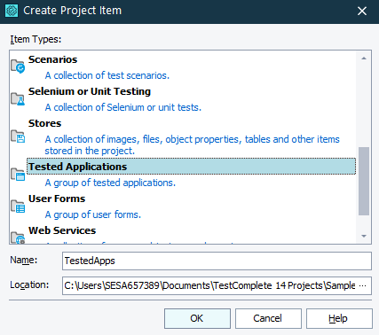

1. Right click on Tested app and select new item to add path for application to test

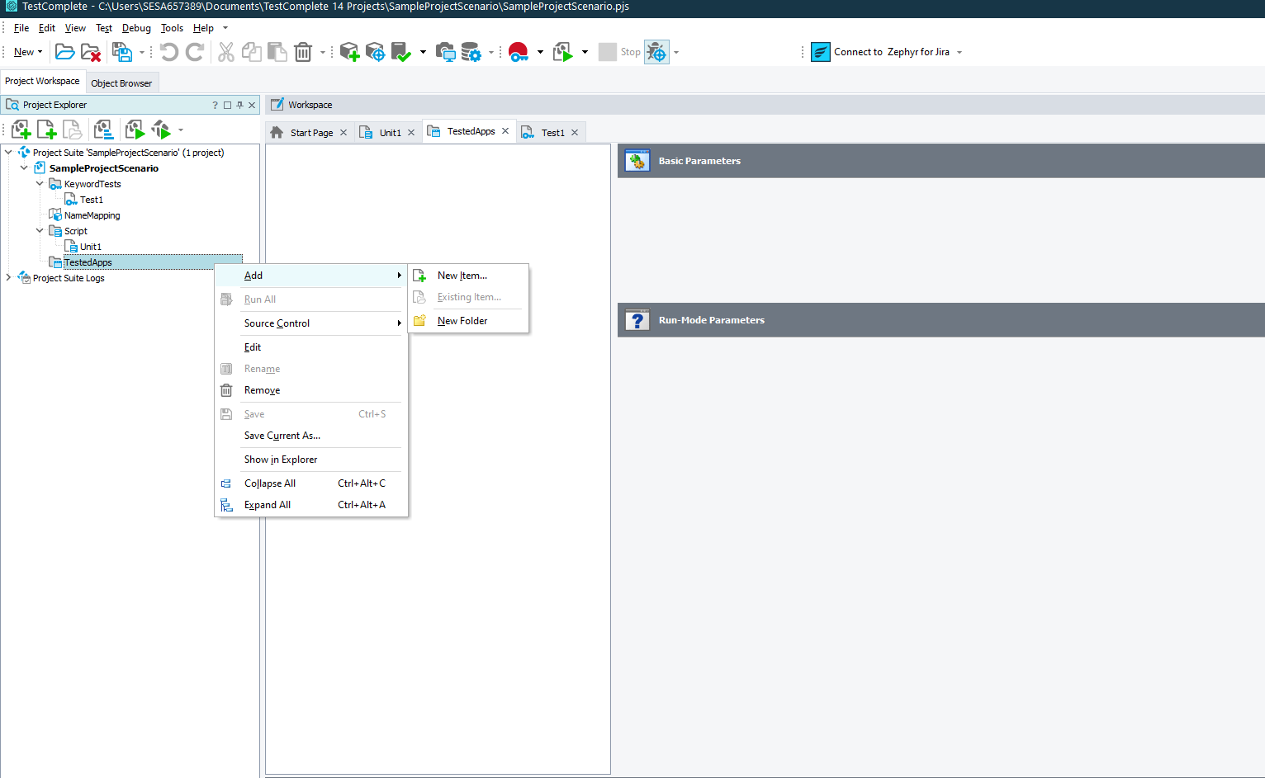

1. Select the type of the application as shown below.

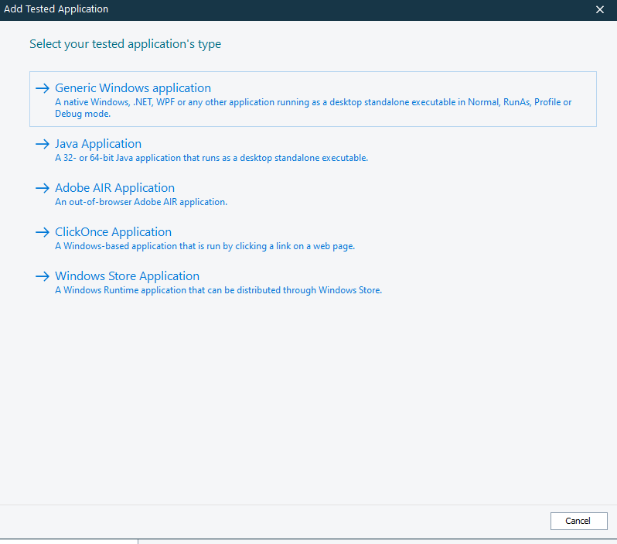

1. Give the path of the application in Application field and click on finish button.

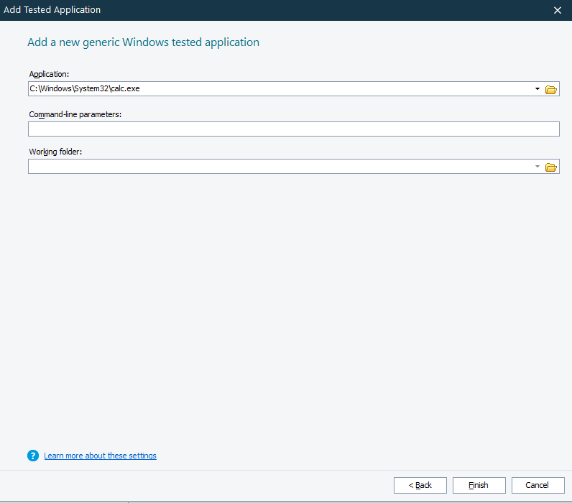

1. Once the application is added ,it looks as shown below.

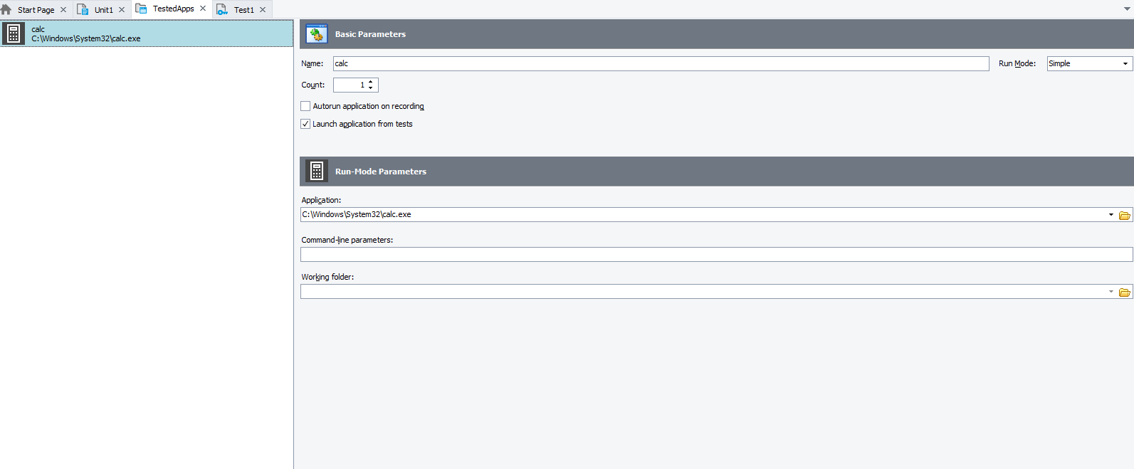

* To spy the object, click on the icon as shown below.

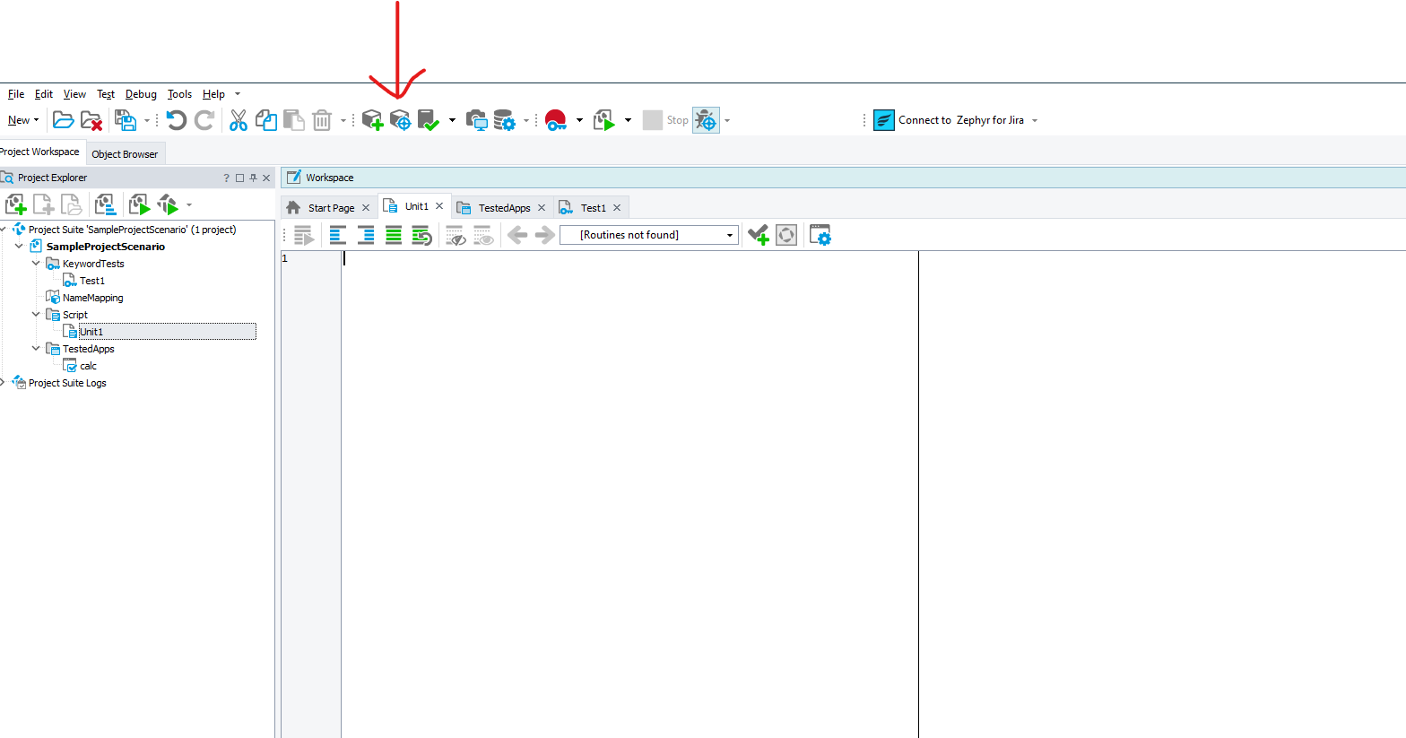

* Once the icon is clicked popup appears as shown below.

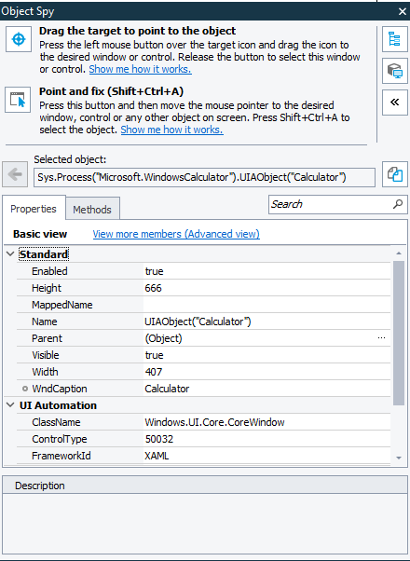

* Drag the icon to the particular field to find the path of that field.

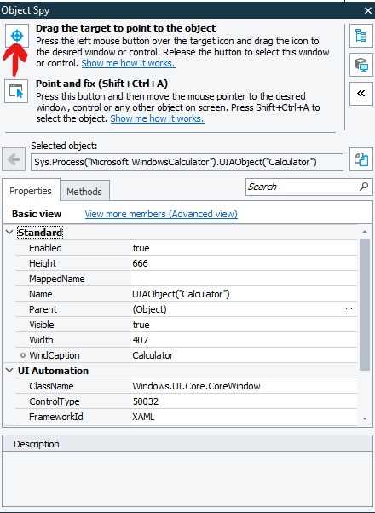

* Select the icon to get property and method for the following field.

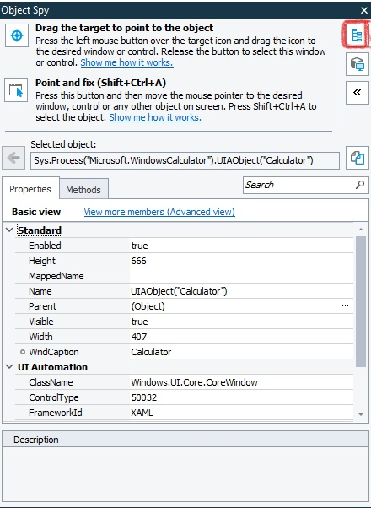

* Once the icon is clicked, properties and methods are available to write a code as shown below.

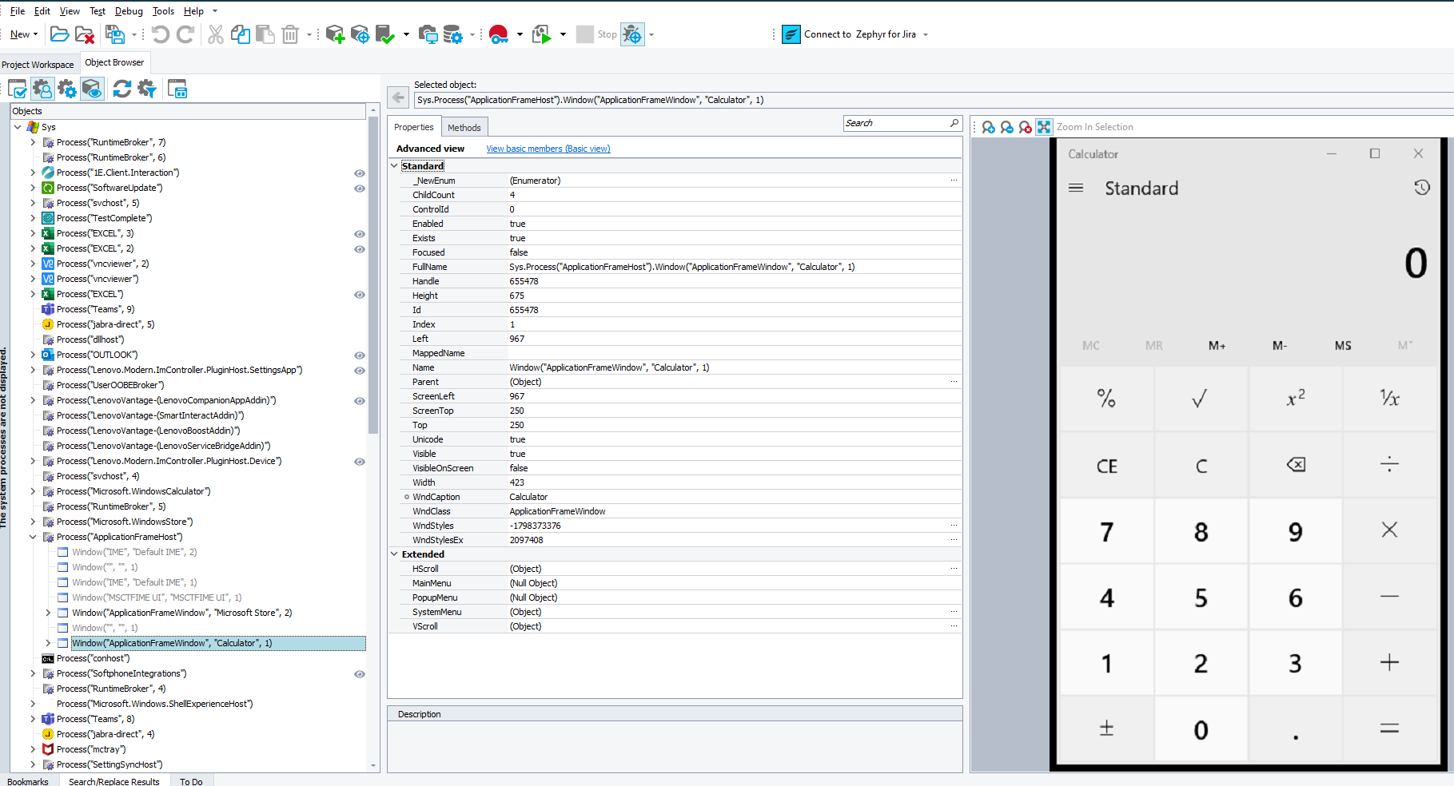

* Tool for writing a code is shown below, under script create a folder and start writing a code.

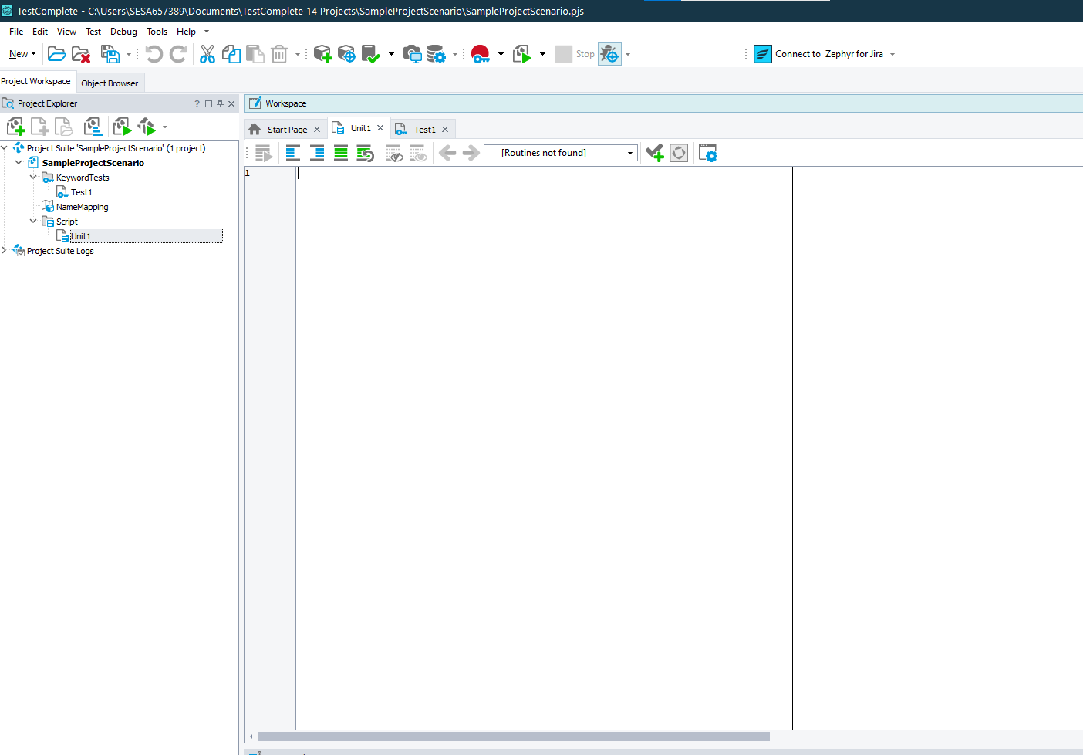

* There are two ways of writing a code

1. Using USEUNIT
2. Direct code

Using USEUNIT:

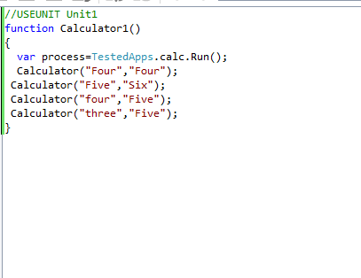

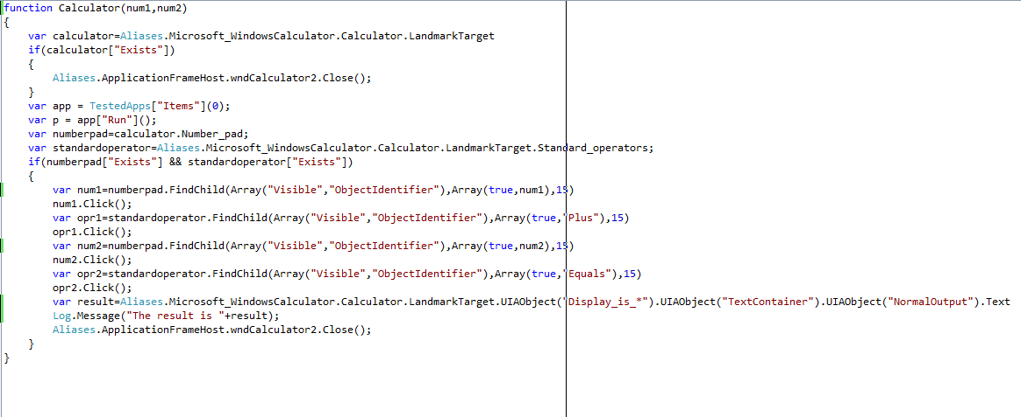

Direct Code:

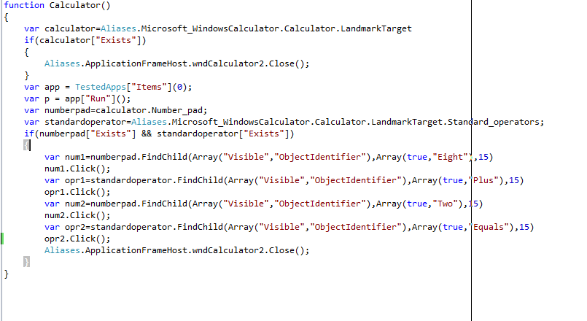

* There are two ways to do that i.e Using Record keyword test and Record script.
* After code is written ,we need to run the code .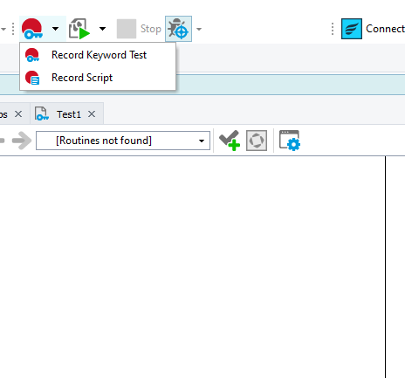

1. **Test Automation Framework:**

Test automation frameworks are a set of rules and corresponding tools that are used for building test cases.

* Language used: Java script ,C#
* Type of framework: Hybrid testing framework
* Reusable Component: We have maintained separate file like
* Page: that holds the functionality of that particular page .
* ObjectRepo: that holds the objects for that particular page
* CommonFunction: that holds the function which are repetitive in nature such as opening the project, delays, closing the project. etc.
* GenericLibrary: that holds database related function for objects identification
* Test Data :We used JSON file for holding the objects and data file
* Screenshot: We have used stores folder in our framework to capture screenshots of images,tables,files
* Testcase Execution:
* ExecutionPlan: To run regression testcases, smoke testcases, sanity testcases we make suits to run manually
* CI/CD tool: To achieve continuous testing,we use Azure devops tool for trigerring testcase
* Version Control:To push and pull the request we are using GIT tool to manage our code.
* Reports/Log: To get the results of testcase ,we have log files in testcomplete itself .
* When object is not able to spy ,then need to add window object to the tools as shown below.Click on Tools tab ,select Current project properties option as shown below.

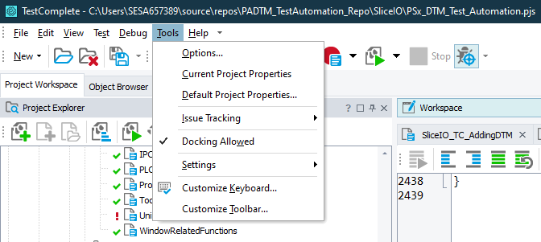

* After that window will look like this and click on Open Applications option.

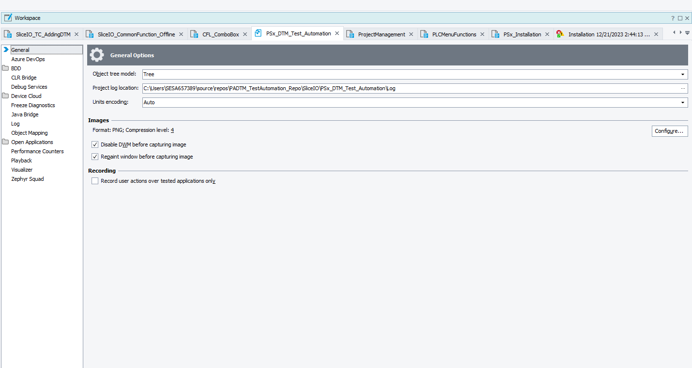

* Select Text Recognition option

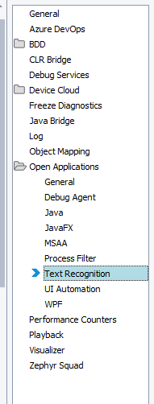

* Click on Add button and paste window name as shown below.

